**Emerging from the Pandemic:  Balancing Academic Rigor with Social Emotional Competencies Within Your PBIS Framework**

**Notes and Action Planning Guide**

|  |
| --- |
| **What Phase of Recovery is your community in?** |

|  |  |  |
| --- | --- | --- |
| **Phase** | **What it looks like** | **What it feels like** |
| **Immediate Crisis Response** | * Educational programing is interrupted or significantly disrupted. * Immediate safety procedures not yet established. * Lack of information or misinformation | * Educators students and families may be confused, anxious or scared |
| **Initial Recovery** | * Schools are open (virtually or in person) * Basic safety procedures are established and implemented consistently * Educators may be learning new skills to support modified programming | * Educators students and families may be confused, anxious or scared * Educators and students may be stressed as they learn new procedures and routines |
| **Intermediate Recovery** | * Schools are open (virtually or in person) * Basic safety procedures are established and implemented consistently * Resources, policy, and procedures are being developed to support educational programming | * Educators students and families may experience fatigue, disillusionment, grief, loss, and a wish to return to the way thing were prior to the crisis |
| **Enhanced Implementation** | * Adapted procedures may become permanent * Systems become more flexible and tailored to student and educator need | * Educators, students, and families begin to develop trust in a system that is meeting their needs |

|  |
| --- |
| **What Stage of PBIS implementation are you in?** |

|  |  |
| --- | --- |
| **Getting Started** | **Strengthening** |
| * **There is an explicit commitment to implementation** * **Schools were not implementing with fidelity prior to the crisis** * **District or school teams are in training or action planning stages but have not yet begun schoolwide implementation** | **Schools were implementing with at least tier 1 fidelity prior to the crisis**  **Strong district commitment and infrastructure to support implementation at the school level exists** |



|  |  |  |
| --- | --- | --- |
| **Immediate Crisis Response** | **Actions** | **Resources** |
| ***Both* Getting Started and Strengthening** | * Ensure physical and emotional safety of all * Implement clear communication and resource distribution plan | Readiness and Emergency Management for Schools (REMS) offers a [virtual tool kit](https://rems.ed.gov/virtual-toolkit/index.html) to support school and district preparedness as well as [topic-specific resources](https://rems.ed.gov/ResourcesToSupportEMP) . |

|  |  |  |
| --- | --- | --- |
| **Initial Recovery** | **Actions** | **Resources** |
| **Getting Started** | * Prioritize staff wellness * Invest in positive, predictable, safe & equitable tier 1 classroom practices | Staff Wellness [webinar](https://nam10.safelinks.protection.outlook.com/?url=https%3A%2F%2Fwww.youtube.com%2Fwatch%3Fv%3Dl6aRIeMM3Ic&data=04%7C01%7Cjennifer.freeman%40uconn.edu%7C83fd6db57c644a0525f708d8d9aebe10%7C17f1a87e2a254eaab9df9d439034b080%7C0%7C1%7C637498695920224897%7CUnknown%7CTWFpbGZsb3d8eyJWIjoiMC4wLjAwMDAiLCJQIjoiV2luMzIiLCJBTiI6Ik1haWwiLCJXVCI6Mn0%3D%7C2000&sdata=8KdXFOwZQlW9RSkiGtpmtf7QlLN5VkzFn8xpiSIYyRs%3D&reserved=0) and [DRAFT brief](https://drive.google.com/file/d/1eFtKhdOJqWXKMa2PffuLvHi6_Onw-E0u/view?usp=sharing)  [Supporting and Responding to Behavior](https://assets-global.website-files.com/5d3725188825e071f1670246/5d65b0e545315207b297d7c3_supporting%20and%20responding%20to%20behavior.pdf) Classroom Practices  Building Habits for Classroom Practices [Webinar](http://www.pbis.org/video/building-habits-of-effective-practice-webinar) and [Brief](https://assets-global.website-files.com/5d3725188825e071f1670246/6035475ae3842049349ba1b2_Habits%20of%20Effective%20Classroom%20Practice%2012.14.20%20(Long%20Template).pdf) |
| **Strengthening** | * Enhance existing tier 1 supports to teach & reinforce new protocols * Include mental health supports | [Supporting Schools During and after Crisis](https://www.pbis.org/resource/returning-to-school-during-and-after-crisis)  [Teaching Social-Emotional Competencies through a PBIS Framework](https://www.pbis.org/resource/teaching-social-emotional-competencies-within-a-pbis-framework) |

|  |  |  |
| --- | --- | --- |
| **Intermediate Recovery** | **Actions** | **Resources** |
| **Getting Started** | * Invest in tier 1 practices school-wide to establish a positive, predictable, and safe environment * Use existing data to screen & match student to supports | Staff Wellness [webinar](https://nam10.safelinks.protection.outlook.com/?url=https%3A%2F%2Fwww.youtube.com%2Fwatch%3Fv%3Dl6aRIeMM3Ic&data=04%7C01%7Cjennifer.freeman%40uconn.edu%7C83fd6db57c644a0525f708d8d9aebe10%7C17f1a87e2a254eaab9df9d439034b080%7C0%7C1%7C637498695920224897%7CUnknown%7CTWFpbGZsb3d8eyJWIjoiMC4wLjAwMDAiLCJQIjoiV2luMzIiLCJBTiI6Ik1haWwiLCJXVCI6Mn0%3D%7C2000&sdata=8KdXFOwZQlW9RSkiGtpmtf7QlLN5VkzFn8xpiSIYyRs%3D&reserved=0) and [brief](https://assets-global.website-files.com/5d3725188825e071f1670246/603e71f522255982d6b92523_Building_a_Culture_of_Staff_Wellness_Through_MTSS_FINAL.pdf)  [Supporting and Responding to Behavior](https://assets-global.website-files.com/5d3725188825e071f1670246/5d65b0e545315207b297d7c3_supporting%20and%20responding%20to%20behavior.pdf) Classroom Practices  Building Habits for Classroom Practices [Webinar](http://www.pbis.org/video/building-habits-of-effective-practice-webinar) and [Brief](https://assets-global.website-files.com/5d3725188825e071f1670246/6035475ae3842049349ba1b2_Habits%20of%20Effective%20Classroom%20Practice%2012.14.20%20(Long%20Template).pdf) |
| **Strengthening** | * Refine tier 1 based on data * Enhance screening protocol * Develop/enhance tier 2 & 3 supports to match identified needs | [Data-based Decision Making](https://www.pbis.org/topics/data-based-decision-making)  [Systematic Screening](https://www.pbis.org/topics/data-based-decision-making)  [Tier 2](https://www.pbis.org/pbis/tier-2) and [Tier 3](https://www.pbis.org/pbis/tier-3) Overviews |

|  |  |  |
| --- | --- | --- |
| **Enhanced Implementation** | **Actions** | **Resources** |
| ***Both* Getting Started and Strengthening** | * Use data to make ongoing adjustments to an evidence-based, trauma-informed & equitable continuum of supports | [Integrating a Trauma-Informed Approach within a PBIS framework](https://assets-global.website-files.com/5d3725188825e071f1670246/602ff0a2995a3f8ac1067813_Installing%20an%20Interconnected%20Systems%20Framework%20at%20the%20School%20Level.pdf)  [Culturally Responsive Field Guide](https://assets-global.website-files.com/5d3725188825e071f1670246/5d70468ef10ca28bb416e7b0_pbis%20cultural%20responsiveness%20field%20guide.pdf)  [Integrated TFI Companion Guide](https://assets-global.website-files.com/5d3725188825e071f1670246/60353dbba570c07cbf23f883_Integrated_TFI_Companion_Guide_1.22.21.pdf) |

**Based on your communities crisis recovery phase and your level of PBIS implementation, Identify your key priorities and action steps right now:**

|  |
| --- |
| **How do we organize supports to meet new student need?** |



**Academic Rigor vs Mental Health and Wellness- Which do we need more right now?**

* “Normal” in high school includes academics and even some stress.
* Maintaining academic **routines** can reduce stress and uncertainty.
* Holding high (but appropriate) standards with **encouragement and support** communicates trust and confidence in student abilities
* Providing **flexibility** on modality and timing allows for unexpected issues without modifying expectations
* Teaching **self-management** and **wellness** strategies and prompting students to use them allows students to handle stressful situations

**Instruction is a Protective Factor**

**[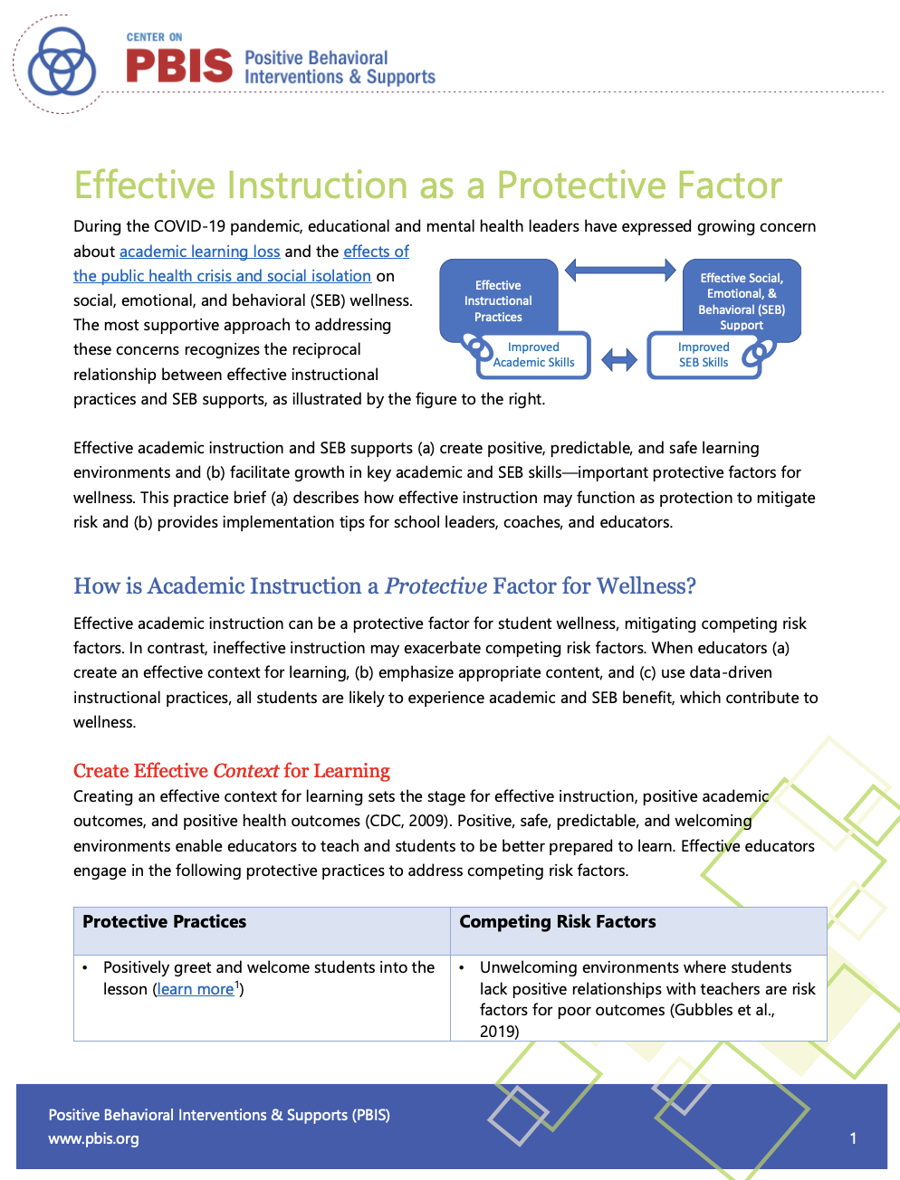](https://assets-global.website-files.com/5d3725188825e071f1670246/60353ff902fbf7f24aa6cc43_Effective_Instruction_as_Protection_1.21.2020.pdf)**

|  |
| --- |
| **Tier 1: Build on what you have!** |

|  |  |  |  |
| --- | --- | --- | --- |
|  | Description | SEB Examples | Academic Examples |
| **Connect** | Enhance relationships among educators, students, and families to promote effective communication during times of disrupted learning.  Check in with students daily and with families regularly to identify support needs as they emerge | * Positive Greetings at the ”door” * Individual and small group “check ins” * Peer-peer connection time in breakout groups | * Structured group activities * Represent student culture/experiences in curriculum |
| **Screen** | Formally or informally screen to efficiently identify students who need more support (related to health, safety, SEB needs, academic concerns). | * Review existing data (e.g., attendance, climate surveys) to determine need * Family/student wellness check * Formal SEB screener | * Frequently identify academic need through existing data (e.g., course grades) * Ensure students and families have access to academic data |
| **Support** | Establish a safe environment (in class and/or online).  Teach, prompt, and acknowledge predictable routines, positive expectations and SEB skills.  Bridge expectations (teach connections) across settings (e.g., home, school, community). | * Physical arrangement organized and matches instructional needs * Use matrix to define expectations * Teach predictable routines e.g., class entry routines and warm ups * 5:1 ratio of positive: neg comments * Teach and model routine for asking for help and wellness | * Incorporate academic routines into matrix * Clarify learning goals |
| **Teach** | Effectively teach and prompt critical academic skills, and actively engage students in learning.  Prompt and reinforce expectations and SEB skills throughout instruction.  Provide positive and supportive feedback to support skill development. | * Active engagement * Prioritize SEB skills that provide access to and support academic growth | * Prioritize key academic skills * Offer flexibility on mode/timing and hold high expectations * Engage a gradual release model * Frequent feedback |
| **Monitor** | Continue to monitor implementation and safety, health, SEB, and academic needs to (a) enhance supports for all students and (b) identify students who require more support (Tier 2 or Tier 3) over time.  Match the intensity of monitoring to the intensity of need. | * Collect and use data on student engagement and SEB skill use * Develop boosters/practice for areas of need * Celebrate areas of success | * Regularly monitor comprehension * **Ask students what is and is not working!** |

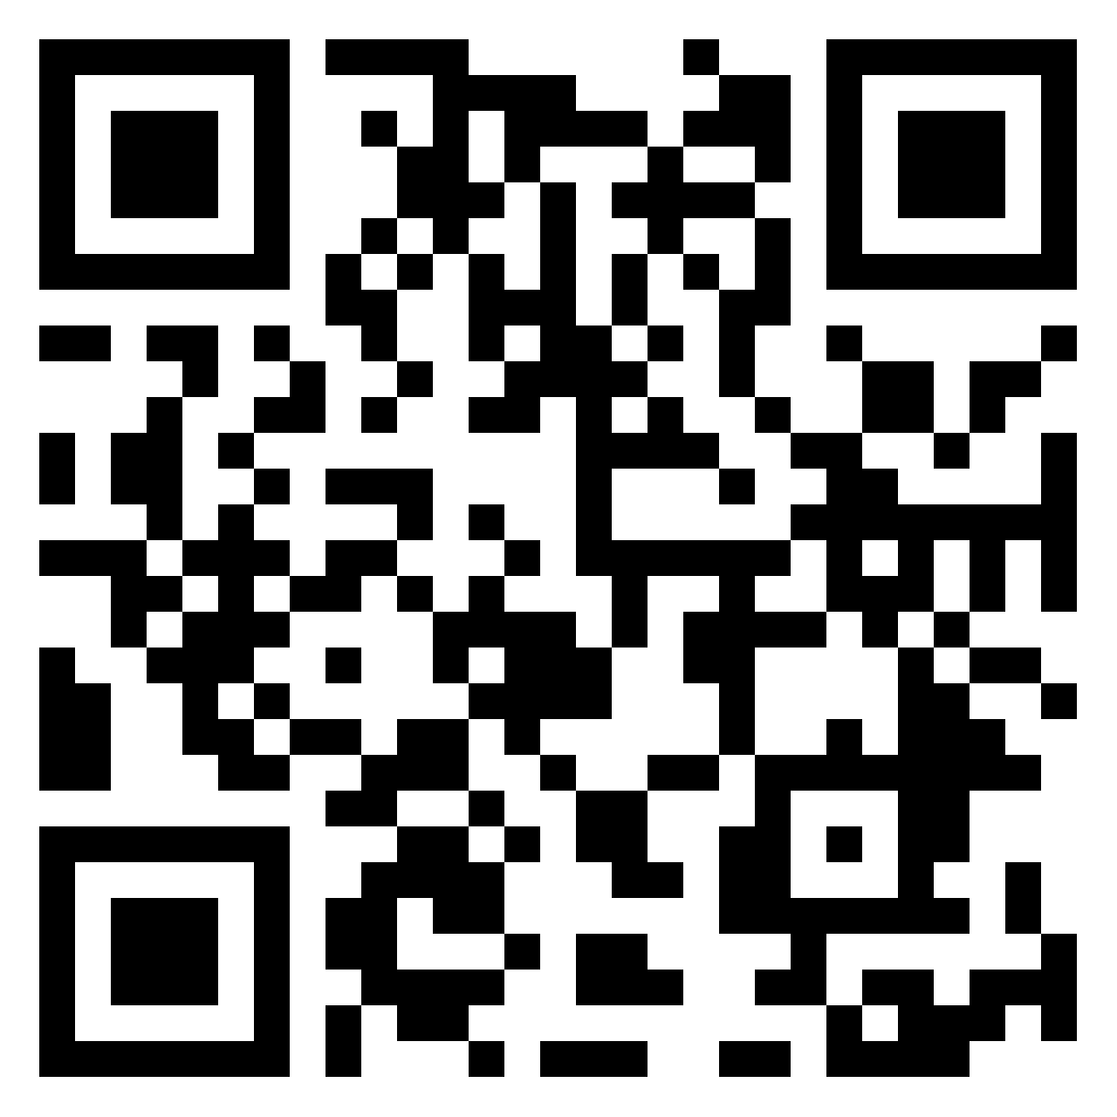

**Share Your Practices** [**Here**](https://padlet.com/jenfreeman09/7wty9x25pydny9vs)**!**

[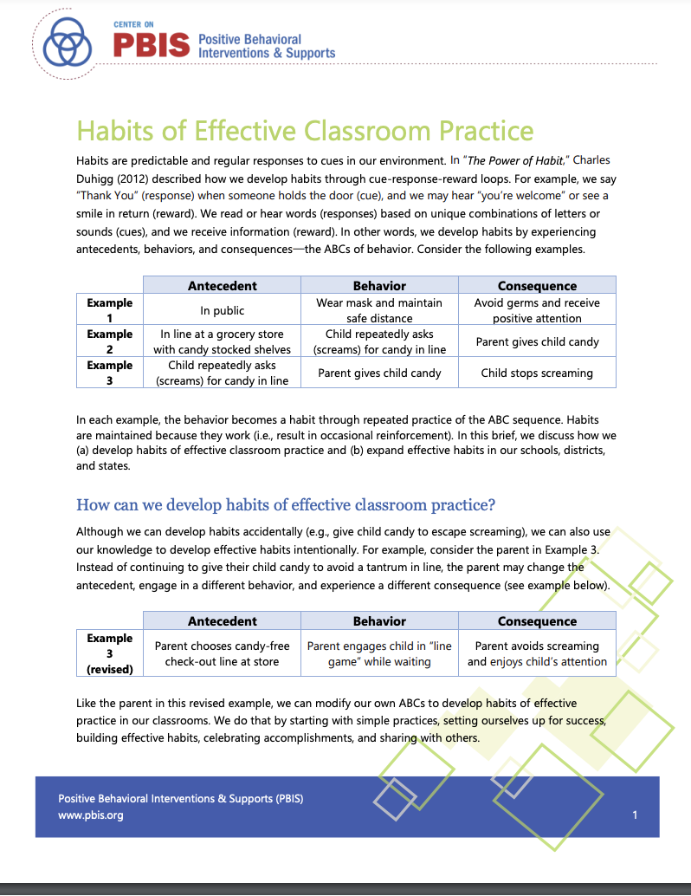](https://assets-global.website-files.com/5d3725188825e071f1670246/6035475ae3842049349ba1b2_Habits%20of%20Effective%20Classroom%20Practice%2012.14.20%20(Long%20Template).pdf)**More is not Better!**

**[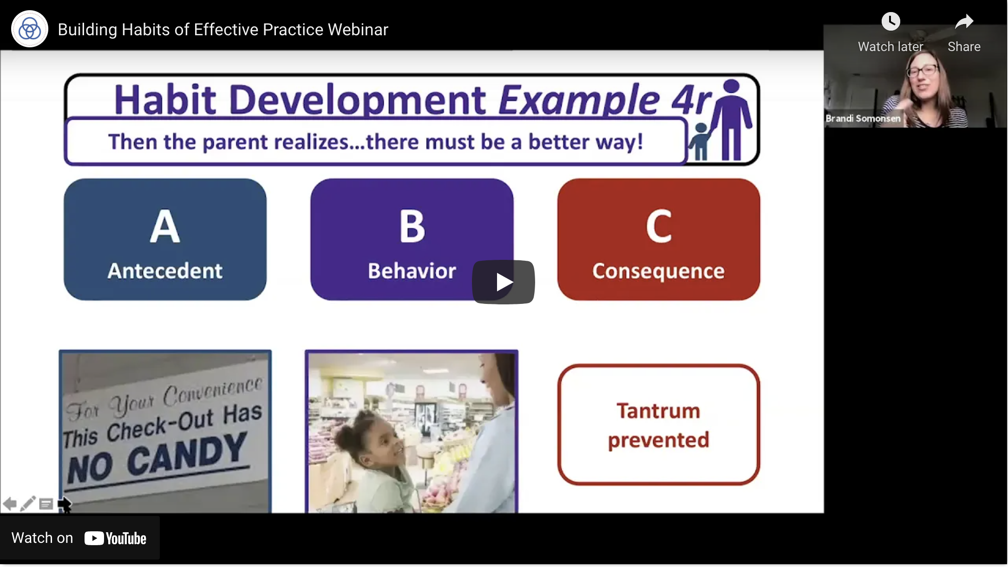](https://youtu.be/2ws0_BGHufU)**

3 Simple Practices that Do it All!

* Positive Greeting at the “door”
* Active Engagement
* Specific Feedback 5:1 Ratio

**Identify priority practices that promote BOTH wellness and academics that you can use to intensify Tier 1: document those here.**

|  |
| --- |
| **Data to Guide Implementation** |

|  |  |  |
| --- | --- | --- |
| **Fidelity Data** | **School-Wide** | **Classroom** |
| **In-Person** | [TFI](https://assets-global.website-files.com/5d3725188825e071f1670246/60108a57b3fa685215c10927_SWPBIS%20Tiered%20Fidelity%20Inventory%20(TFI).pdf) | [CMOT](https://nepbis.org/wp-content/uploads/2020/06/CMOT-5.1.20.pdf) |
| **Remote or Hybrid** | [Remote TFI Walk-through](https://assets-global.website-files.com/5d3725188825e071f1670246/603679158f920d543776c3d9_Remote%20TFI%20Brief%20(Sept%202020).pdf) | [CMOT for Remote or Hybrid](https://nepbis.org/wp-content/uploads/2020/09/CMOT-Administration-Recommendations-for-Remote-or-Hybrid-Learning2.pdf) |

**[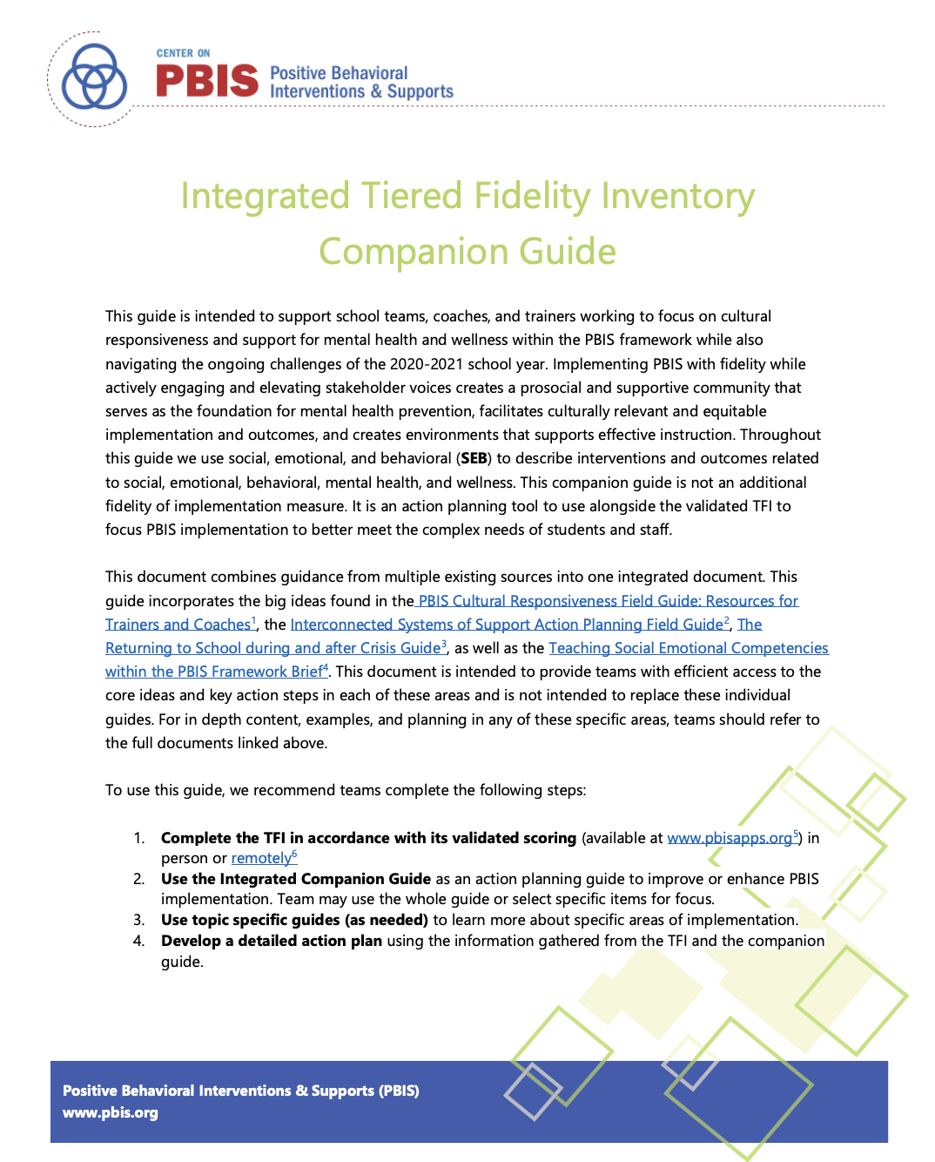](https://assets-global.website-files.com/5d3725188825e071f1670246/60353dbba570c07cbf23f883_Integrated_TFI_Companion_Guide_1.22.21.pdf)**

Integrated TFI Action Planning Guide

|  |  |  |
| --- | --- | --- |
| **Outcome Data** | **Observed** | **Perception** |
| **In-Person** | ODR  Time out of Class  Grades | [School](https://nepbis.org/district-data-tools-resources/) Climate  [Screeners](https://assets-global.website-files.com/5d3725188825e071f1670246/5fcff6599dd5f866a4ccc505_Systematic%20Screening%20for%20Behavior.pdf) |
| **Remote or Hybrid** | [Attendance and Engagement](https://assets-global.website-files.com/5d3725188825e071f1670246/5ff34f3363042168264ed6e3_Remote%20Attendance%20Brief%20Revised%2012.23.2020.pdf) | [School Climate for Remote or Hybrid](https://nepbis.org/district-data-tools-resources/) |

**[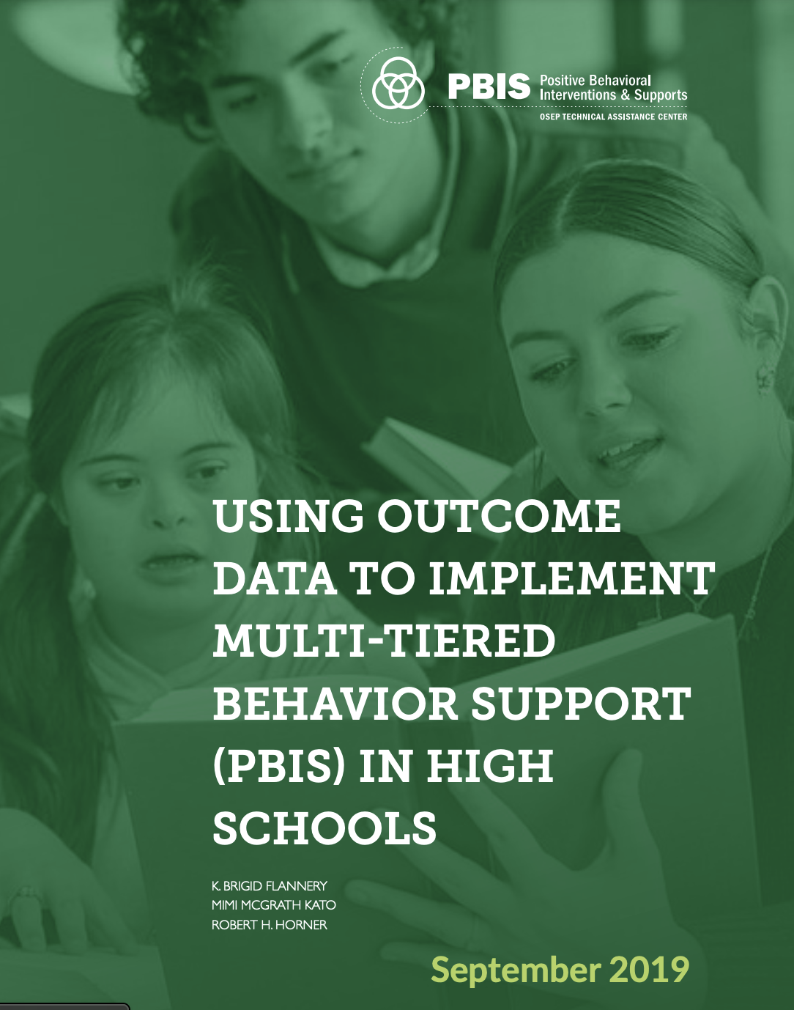](https://assets-global.website-files.com/5d3725188825e071f1670246/5e5028711d6507a954003009_Using%20Outcome%20Data%20to%20Implement%20Multi-tiered%20Behavior%20Support%20(PBIS)%20in%20High%20Schools.pdf)**

Using Data in High Schools



**Identify Fidelity and Outcome measures that align with your selected practices: Document data source and implementation plans here.**

**Wrap up Thoughts and Key Action Plan Items**